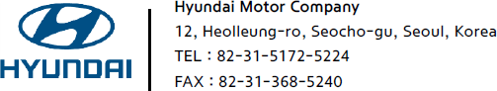


GSO Conformity Certificate CCR No. 502673
Motor Vehicles
Manufacturer: Hyundai Motor Manufacturing Czech s.r.o.
Country of Origin: CZECH REPUBLIC, Country of Production: CZECH REPUBLIC
To: GCC Standardization Organization (GSO)
We hereby certify that the vehicles manufactured by Hyundai Motor Manufacturing Czech s.r.o.
* Type: Hyundai Tucson 1.6 DSL SUV 4x2 5 Doors
* VlN number: TMAJB81AGSJ563803
* Model Year: 2025 * Produced in and after: Month 07 Year 2025
* Category: Passenger Car
Will satisfy the G50 Technical Regulations Nos: 34:20o7, 3s:2007, 36:2005, 37:2012, 38:200s, 392005, 40:2011,42:2015, 48:1984, 51:20o7, 52:2007, 53.2007, 9611988. 9721988, 9811988, 9921988,13522007, 13622007. 29021994. 4119:1994,42o:1994,421:2005,422:200s.1040:20001041:2000,1042:2000,1053:2000,1503:2010,1598:2002,1624:2002,1677:2003,1708:2o0s,1780:2010,1781:2006,1782:2008,1783:2006,1784:2o0e.Gsolso1585:2008,GSO lSO 3537:2008, GSO 150 3538:1997, G50 ECE13H:2012,GSO ECE13H-1:2012,GSO ECE13H-2:2012,GSO ECE 13H-3:2012, GSO ECE13H-4:20l2, GSO ECE13H-S:2012,GSO ECE 13H-6:2012 and the standards in the country of origin accepted by GSO in the case that no GSO technical regulations and standards are available.
All the essential technical data are as follows:
1. Weights
a. Maximum Vehicle Weight: 2105 kg b. Curb: 1650 kg
c. Maximum Axle Weight: Front: 1260 kg Rear: 1200 kg
2. Dimensions
a. Length: 4500 mm b. Width: 1865 mm
c. Height: 1650 mm d. Wheelbase (Fl R1) 2680 mm e. Track: Front: 1615 mm Rear: 1622 mm
3. Type of chassis and body: Monocoque
4. Number of Passengers: 5(Including the Driver)
5.Engine: Diesel a. Cylinders: 4 b. Displacement: 1598cc c. Air intake: Turbo
d. Net Engine Power: 100 kW at 4000 rpm Pollutant Limit comply with Euro 6e.
6. Transmission: Automatic
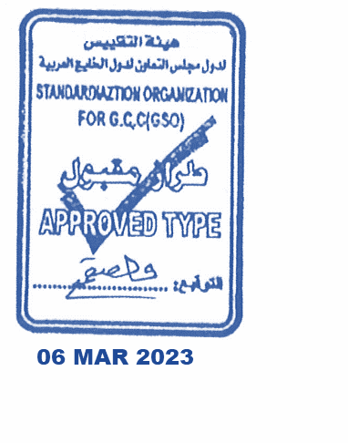
7. Brakes a. Service Brakes: Hydraulic b. Emergency Brakes: Combined with the service brake
8. Fuel Economy a. Motor Vehicle Class: Passenger Car b. FE (CAFE) Combined: 18.0 km/L - Very Good
9. Any other information or local standards to be compiled: for member countries mentioned in the Annex of the list of Technical Regulations for MV 2025MY-D3, when exporting to those countries.


Seung wook Park
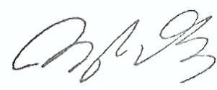
General Manager
Certification & Regulation Team
11 OCT 2025 20252025

